**Connect to Redcap Project using API**

* Go to Redcap -> api playground and use the following setting.

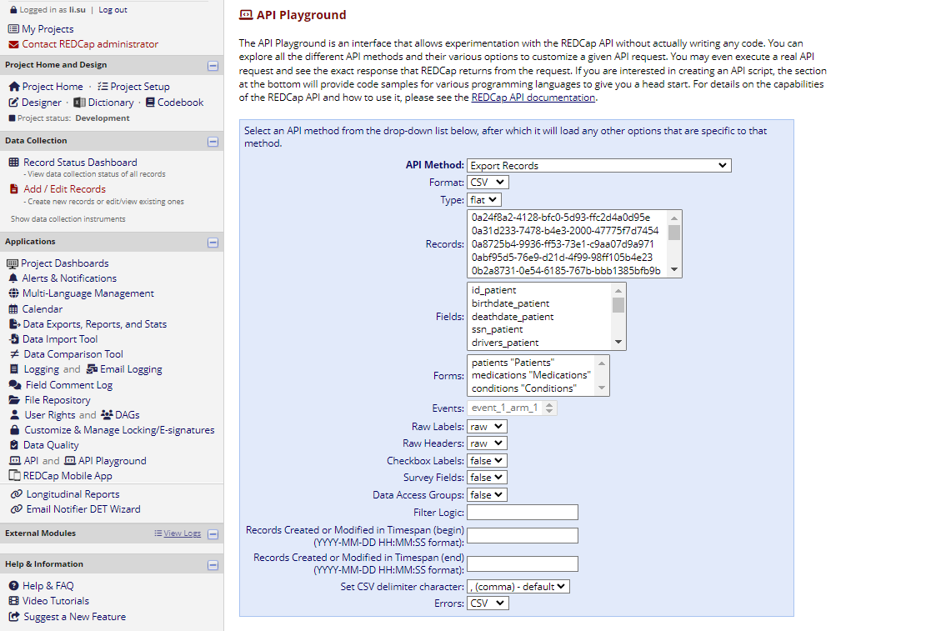

* This automatically generate the necessary code for getting the csv file using R

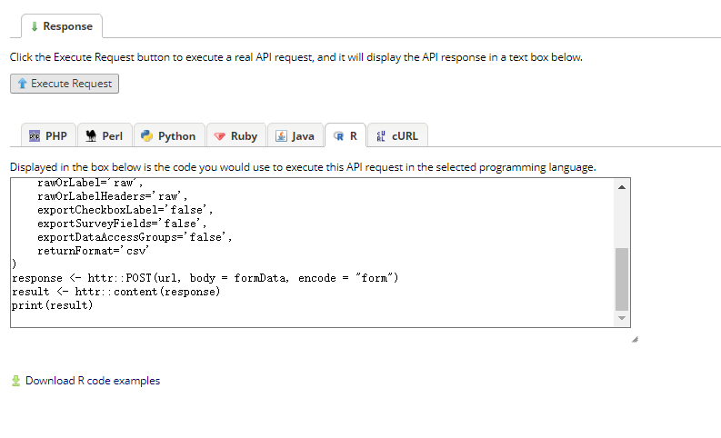

* Copy and paste them in R studio. Don’t forget to install the necessary package.

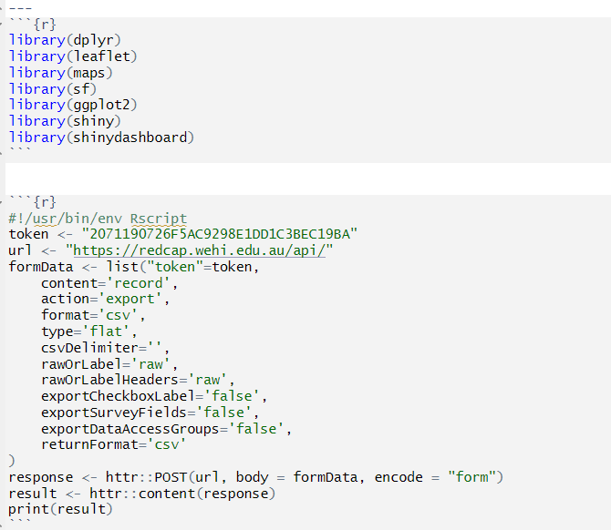

* Run this chunk and your csv will be saved as a df called “result”. Notice that this step will take minutes if the size of csv is huge. (fyi. Size of 200,000 records takes about 2 min)

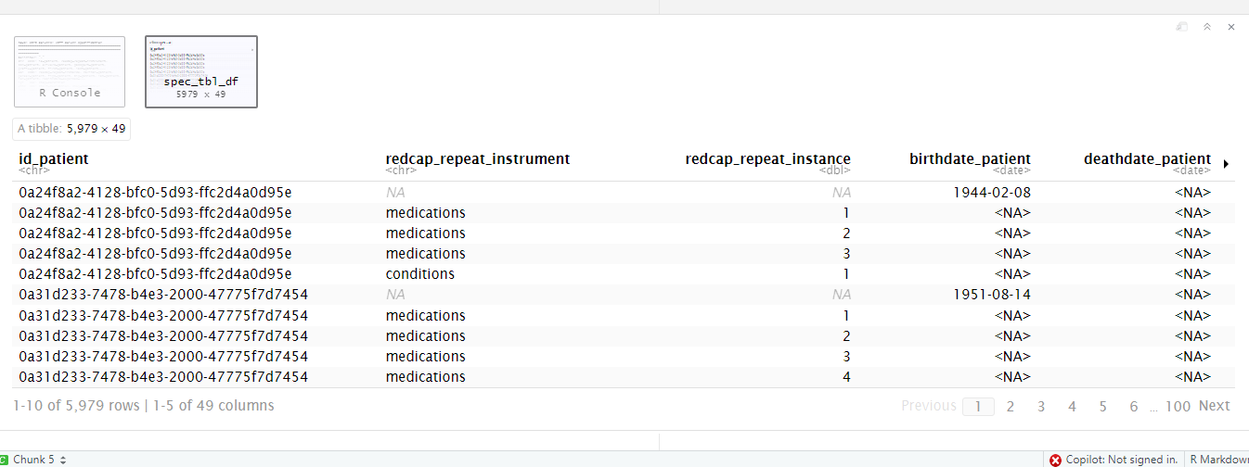

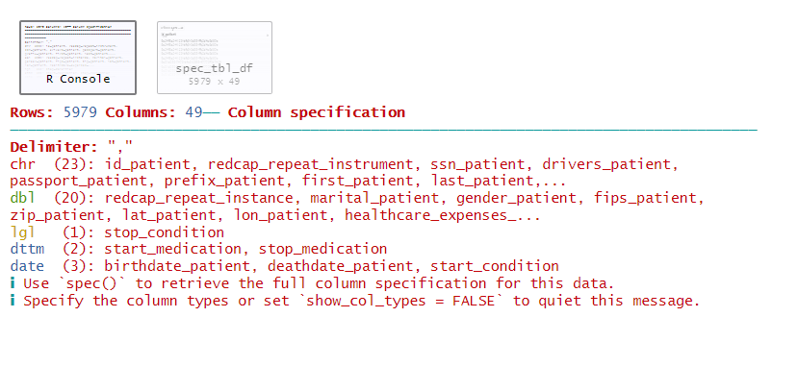

* With the API token, this can be done without using WEHI R Shiny server.